2200031128 CH BHAVANA
WEEK 7 TASK 5
Estimated time to complete this lab: 60 minutes.
Create a React App named “bloggerapp” in with 3 components.

- Book Details
- Blog Details
- Course Details

Implement this with as many ways possible of Conditional Rendering.

- Creating a react app based on the given question

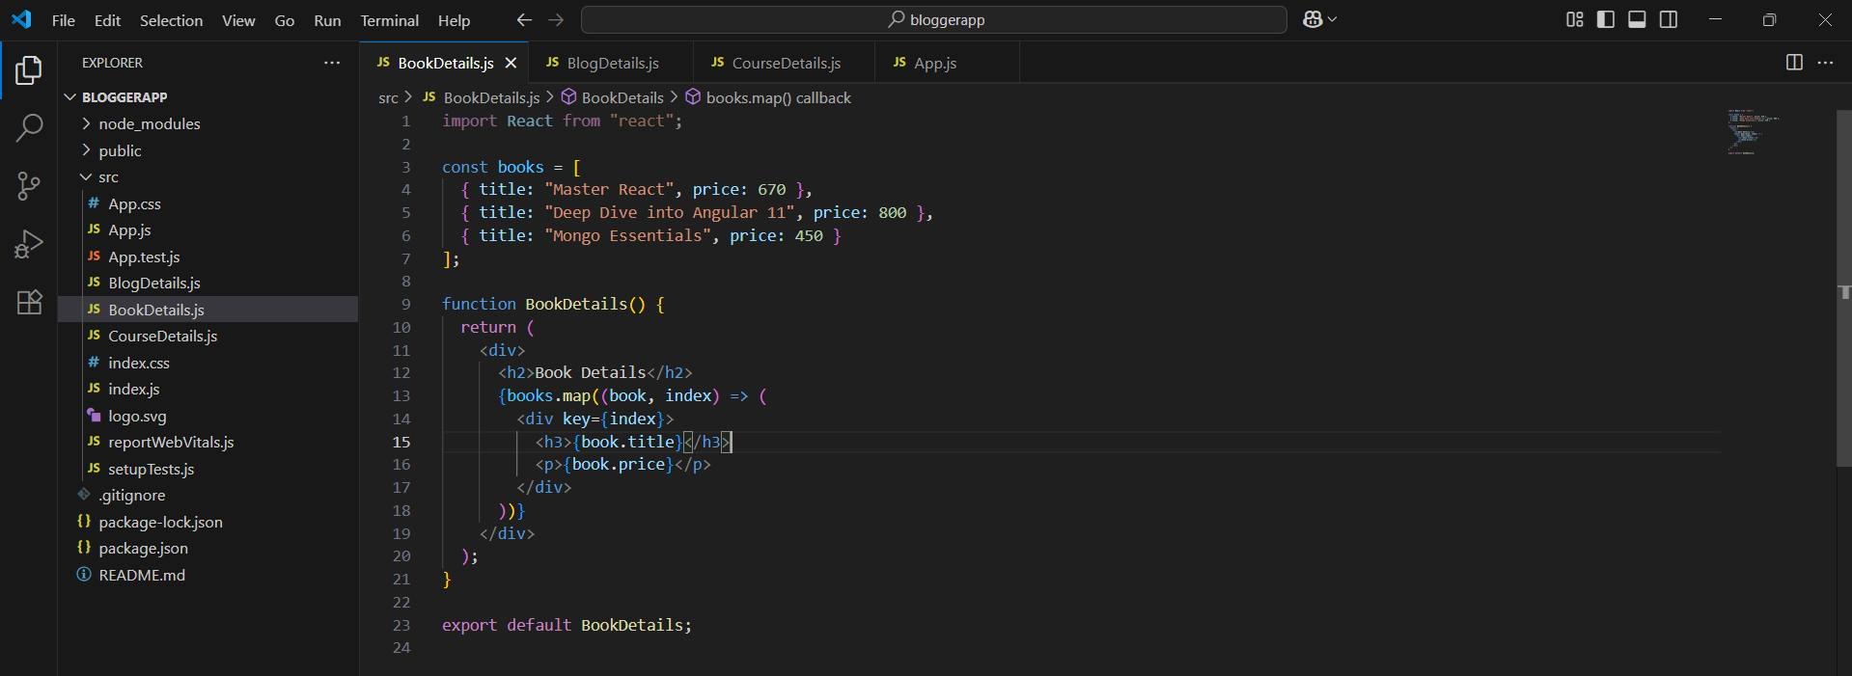
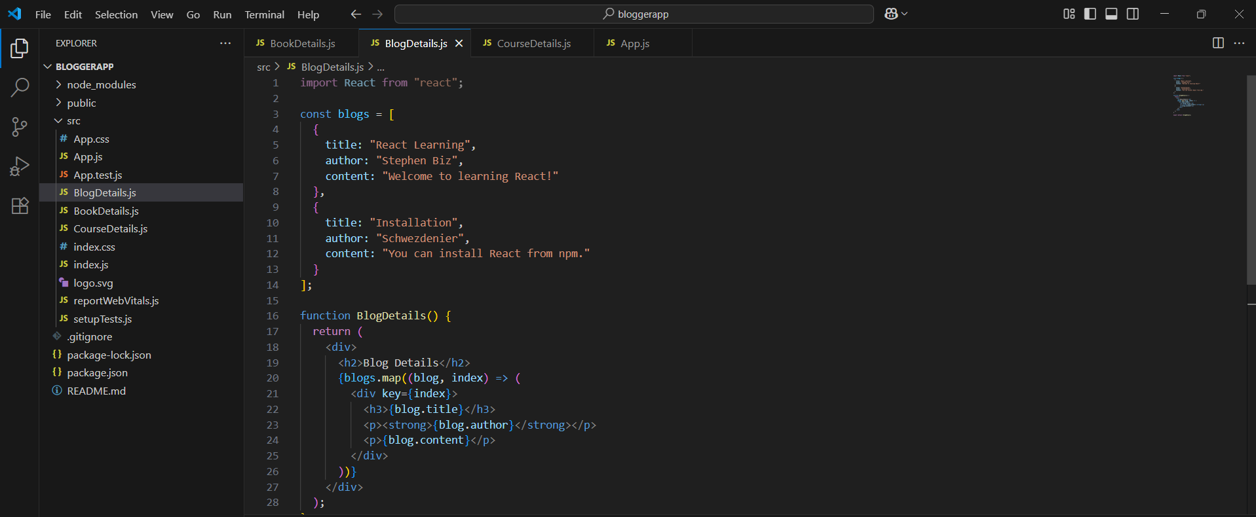
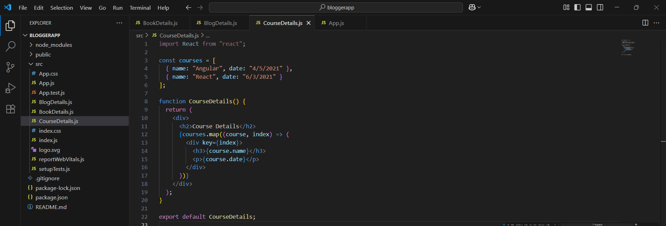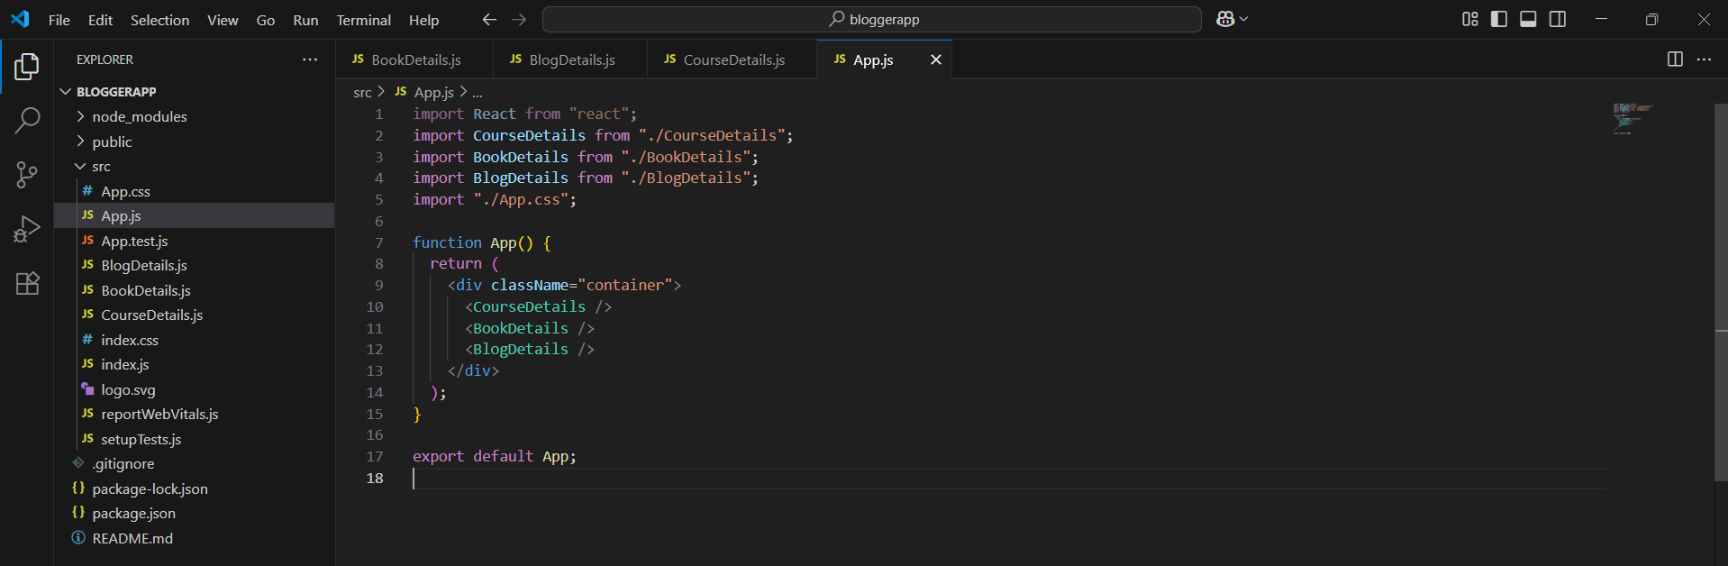
OUTPUTS:
